CSR CERTIFICATION GENERATION



Table of contents

1. Purpose

2. Scope
2.1. In Scope
2.2. Out of Scope

3. Prerequisites

4. Procedure

5. Version Control
5.1. Purpose
5.2. Revision History

- Purpose

The document is prepared to provide the steps to generate the CSR certification in Linux servers.

- Scope

2.1. In Scope
2.2. Out of Scope

- Prerequisites

3.1. Get the RITM from the requestor with proper details.

- Procedure

4.1. Validate the request
4.2. Login to the server
4.3. Open /tmp
4.4. Under /tmp directory create a new file name “Servername_ssl.cnf”

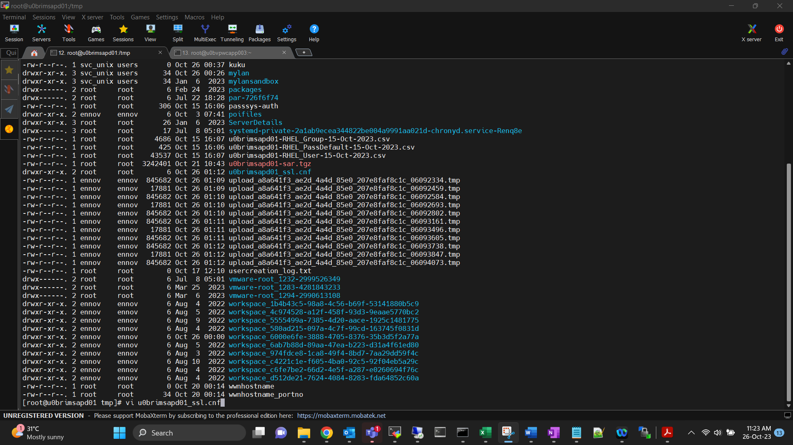
4.5. Feed the following entries in the “servername_ssl.cnf” file (As per the request)
[req]
distinguished_name = req_distinguished_name
req_extensions = req_ext
prompt = no
[req_distinguished_name]
C = US
ST = Pennsylvania
L = Canonsburg
O = Mylan, Inc
OU = IT Department
CN = uezvfitwebp01.myl.com

[req_ext]
subjectAltName = @alt_names
[alt_names]
DNS.1 = uezvfitwebp01.myl.com
DNS.2 = fits.viatris.com

4.6. Execute the following command to generate ssl certificate.
“openssl req -new -newkey rsa:4096 -nodes -keyout u0brimsapd01.key -out u0brimsapd01.csr -config u0brimsapd01_ssl.cnf
[change the server’s name for different servers]

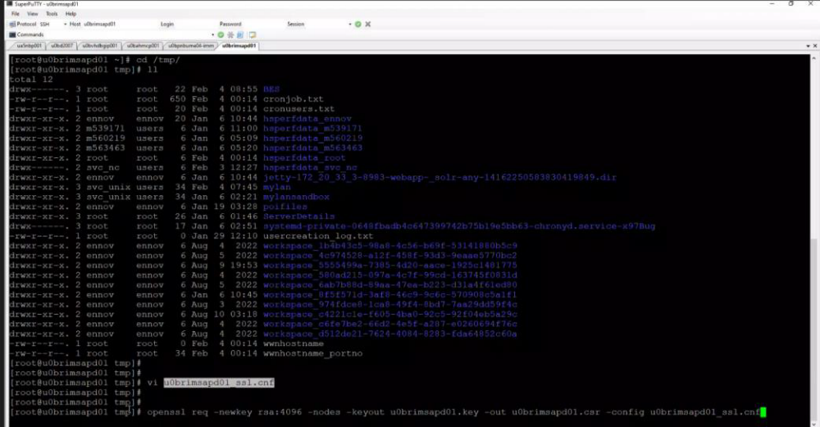

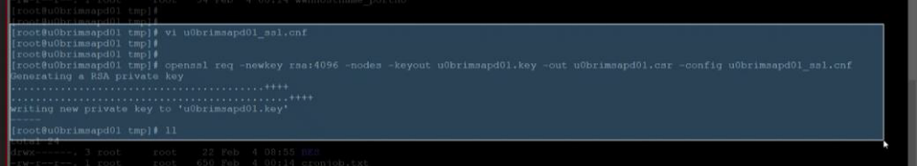

4.7. Now CSR file and its key will be generated under /tmp directory.
u0brimsapd01.csr
u0brimsapd01.key

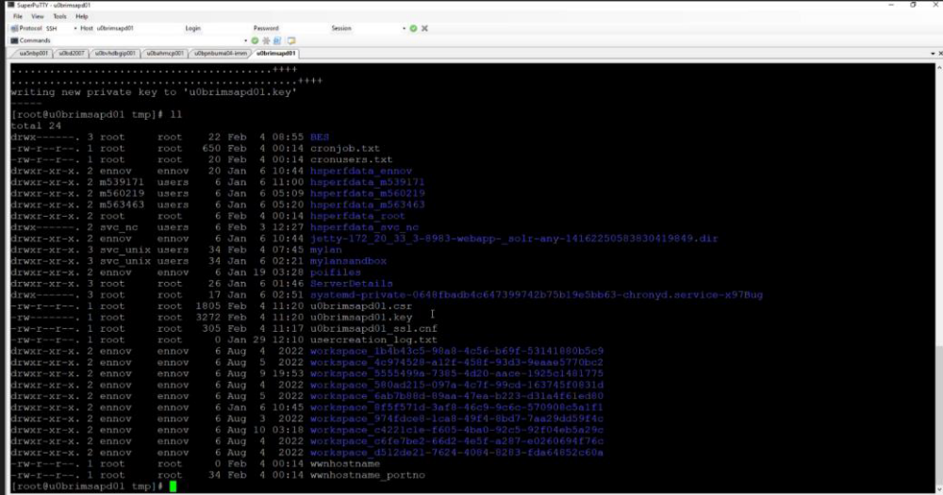

5.Version History

 | Prepared By | Reviewed By | Approved By
Name | Joshva S | Arun R | Ashok kumar R K
Role | Unix L1 | Assistant Manager | Manager
Date | 05-Nov-23
Version | 1. 0 | 1. 0 | 1. 0

